**Project Document**

**GARAGE MANAGEMENT SYSTEM**

# 1. Project Overview

# The Garage Management System is a valuable tool for automotive repair facilities, helping them deliver top-notch service, increase operational efficiency, and build lasting customer relationships. With its user-friendly interface and powerful features, GMS empowers garages to thrive in a competitive market while ensuring a seamless and satisfying experience for both customers and staff

# 2. Objectives

List the specific, measurable goals the project intends to achieve. Examples:

**Business Goals**:



#### **Enhance Operational Efficiency**

* Streamline workflows for repair job assignments and tracking
* Reduce time spent on manual data entry by automating processes.

1. **Improve Customer Experience**

* Provide real-time updates on repair status.
* Offer a seamless booking system for repair appointments.

1. **Increase Revenue**

* Track inventory usage to reduce wastage and manage costs effectively.
* Boost customer retention with personalized offers and timely service reminders.

1. **Strengthen Customer Relationships**
   * Maintain a comprehensive record of customer and vehicle history.
   * Collect and analyze customer feedback for continuous improvement.

**Specific Outcomes**:

1. **Customer Management**
   * Centralized database to store customer and vehicle information.
   * Easy retrieval of customer details and repair history.
2. **Repair Job Tracking**
   * A system to log and monitor repair job details, including status updates and assigned staff.
   * Notifications to customers when repairs are completed.
3. **Inventory Management**
   * A tool to track parts and tools used for repairs, ensuring stock levels are maintained.
   * Alerts for low inventory to prevent shortages.
4. **Staff Productivity**
   * Assign repair jobs efficiently based on staff availability and expertise.
   * Generate reports on staff performance and completed tasks.
5. **Real-time Reports and Dashboards**
   * Insightful dashboards displaying key performance indicators like repair times, revenue, and customer satisfaction.
   * Monthly and quarterly reports for data-driven decision-making.
6. **Automation and Notifications**
   * Automate appointment confirmations and reminders for customers.
   * Send reminders for vehicle maintenance based on history.
7. **User-friendly Interface**
   * Design a simple yet effective interface for staff and customers to interact with the system.

**3. Salesforce Key Features and Concepts Utilized**

#### **1. Custom Objects**

* **Customer Details**:
  + Stores comprehensive customer information, including contact details and vehicle history.
  + Relationships with other objects ensure seamless tracking of customer interactions.
* **Appointment**:
  + Captures repair and service booking details.
  + Fields include appointment date, service type, and assigned staff.
* **Service Records**:
  + Tracks details of completed and ongoing repairs or maintenance tasks.
  + Fields such as service description, status, and vehicle information are included.
* **Billing**:
  + Manages payment information and invoices for services provided.
  + Fields include bill amount, payment status, and payment method.
* **Feedback**:
  + Stores customer feedback on services rendered.
  + Enables analysis of satisfaction levels and identification of areas for improvement.

#### **2. Relationships and Data Management**

* **Lookup Relationships**:
  + Connects related objects, such as linking "Appointments" to "Customer Details."
* **Data Validation Rules**:
  + Ensures accuracy, such as mandatory fields for appointment creation or service records.

#### **3. Automation**

* **Flow Builder**:
  + Automates processes like sending appointment reminders and repair status updates.
* **Validation Rules**:
  + Enforces business logic, e.g., ensuring bill payment is recorded before closing a service record.
* **Approval Processes**:
  + Manages approvals for high-value services or discounts.

#### **4. Reports and Dashboards**

* **Reports**:
  + Tracks metrics like the number of services completed, revenue generated, and feedback scores.
* **Dashboards**:
  + Provides a visual overview of operations, such as upcoming appointments, revenue trends, and customer satisfaction levels.

#### **5. User Interface Customization**

* **Page Layouts**:
  + Customized layouts for each object to enhance user navigation and input efficiency.
* **Lightning App Builder**:
  + Configured dashboards and home pages tailored for staff roles, ensuring quick access to key functionalities.

# 4. Detailed Steps to Solution Design

**TASK 1:**

**Creating Developer Account:**

**Creating a developer org in salesforce.**

1. Go to https://developer.salesforce.com/signup

2. On the sign up form, enter the following details :

3. First name & Last name

4. Email

5. Role : Developer

6. Company : College Name

7. County : India

8. Postal Code : pin code

9. Username : should be a combination of your name and company

This need not be an actual email id, you can give anything in the format : username@organization.com

10. Click on sign me up after filling these.

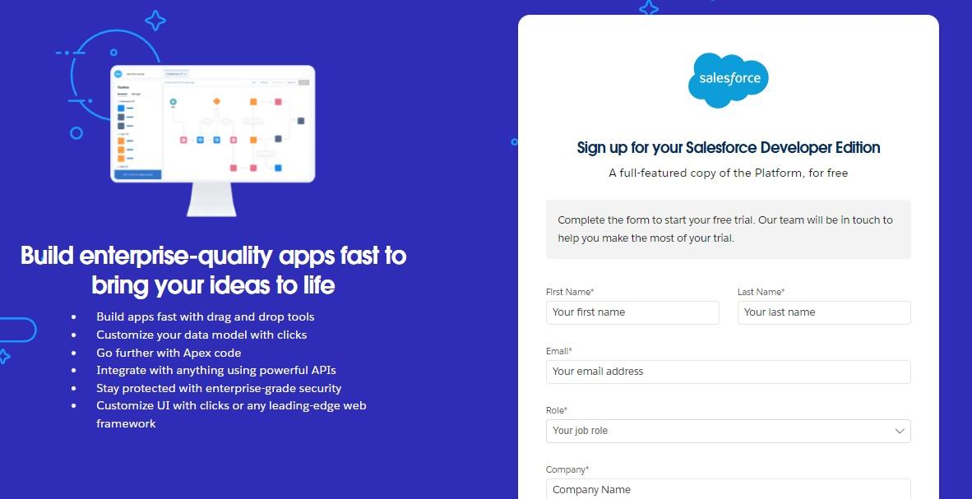

**Account Activation**

1. Go to the inbox of the email that you used while signing up. Click on the verify account to activate your account. The email may take 5-10mins.

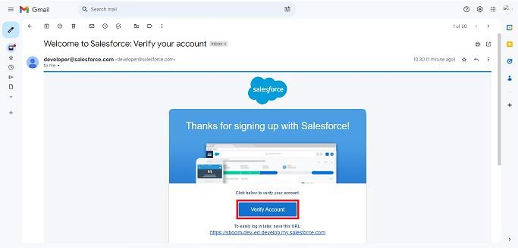

2. Click on Verify Account

3. Give a password and answer a security question and click on change password.

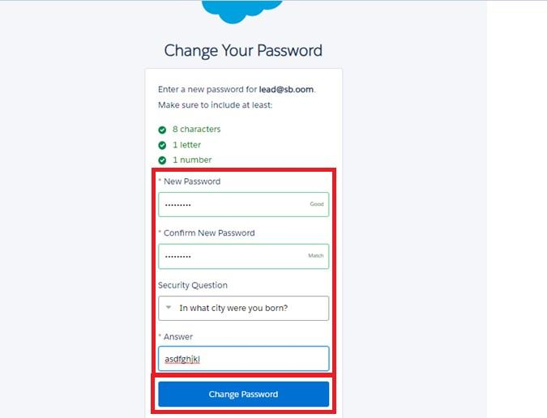

4.Then you will redirect to your salesforce setup page.

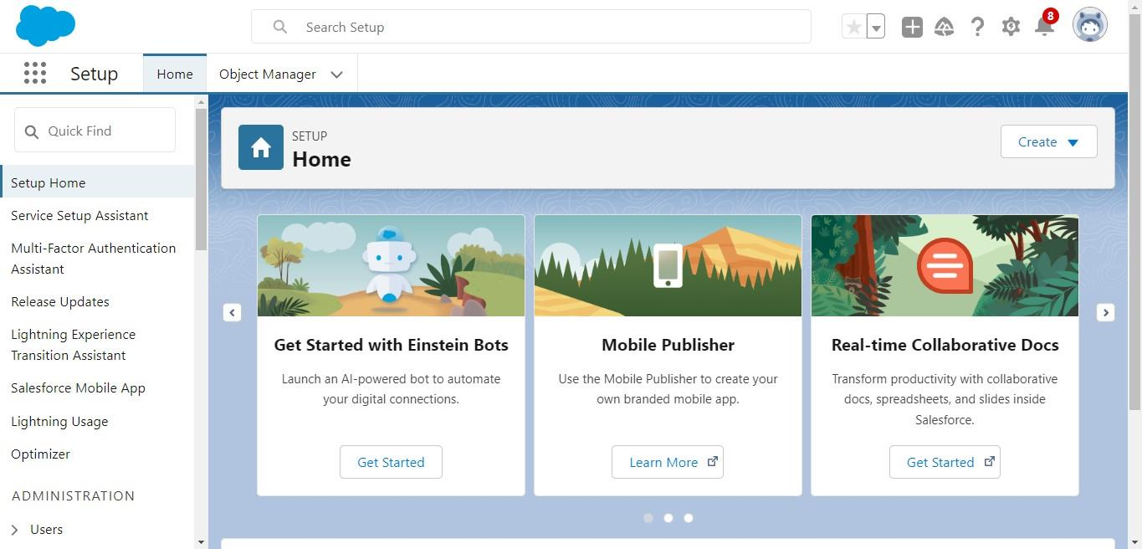

**TASK 2:CREATING THE OBJECTS**

**i)Create Customer DetailsObject**

To create an object:

1. From the setup page >> Click on Object Manager >> Click on Create >> Click on Custom Object.

1. Enter the label name >> Customer Details

2. Plural label name >> Customer Details

3. Enter Record Name Label and Format

● Record Name >> Customer Name

● Data Type >> Text

2. Click on Allow reports and Track Field History,

3. Allow search >> Save

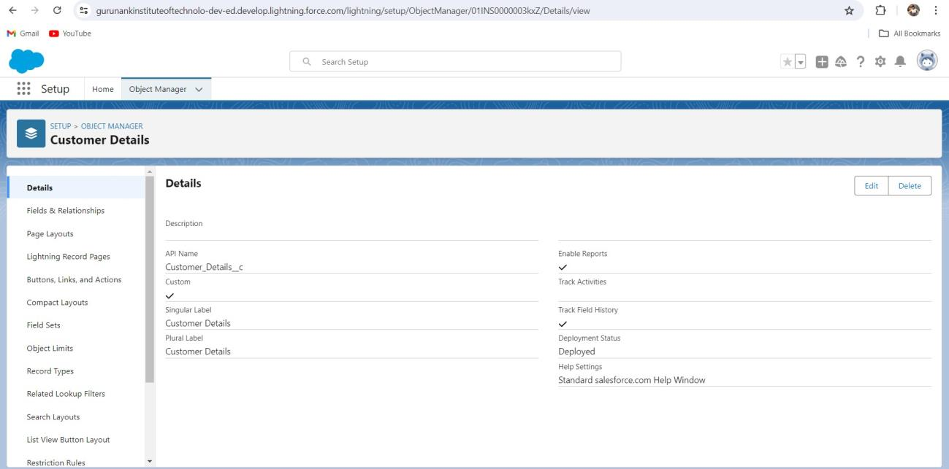

**ii)Create Appointment Object**

To create an object:

1. From the setup page >> Click on Object Manager >> Click on Create >> Click on Custom Object.

1. Enter the label name >> Appointment

2. Plural label name >> Appointments

3. Enter Record Name Label and Format

● Record Name >> Appointment Name

● Data Type >> Auto Number

● Display Format >> app-{000}

● Starting number >> 1

2. Click on Allow reports and Track Field History, 3. Allow

search >> Save.

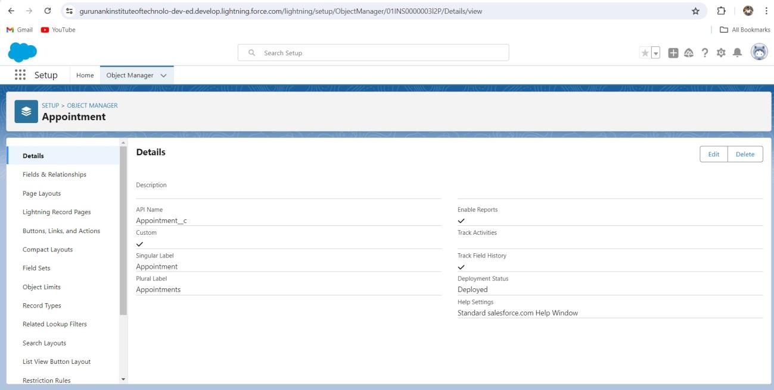

**iii) Create Service Records Object**

**To Create an Object:**

1. From the the setup page >> Click on Object Manager >> Click on Create >> Click on Custom Object.

1. Enter the label name >> Service records

2. Plural label name >> Service records

3. Enter Record Name Label and Format

● Record Name >>Service records Name

● Data Type >> Auto Number

● Display Format >> ser-{000}

● Starting number >> 1 **T**

2. Click on Allow reports and Track Field History,

3. Allow search >> Save.

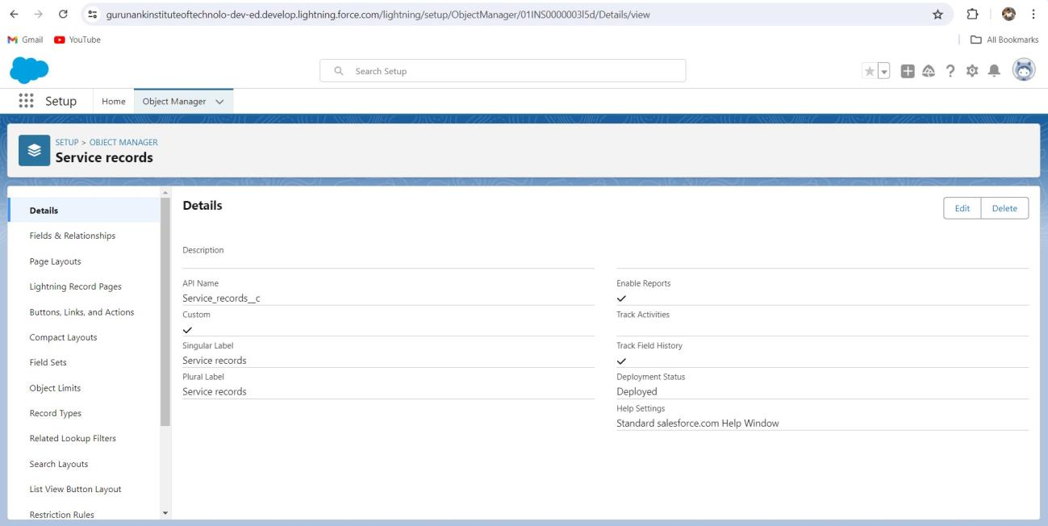

**iv)Create Billing Details And Feedback Object**

To create an object:

1. From the setup page >> Click on Object Manager >> Click on Create >> Click on Custom Object.

1. Enter the label name >> Billing details and feedback

2. Plural label name >> Billing details and feedback

3. Enter Record Name Label and Format

● Record Name >> Billing details and feedback Name

● Data Type >> Auto Number

● Display Format >> bill-{000}

● Starting number >> 1

2. Click on Allow reports and Track Field History,

3. Allow search >> Save.

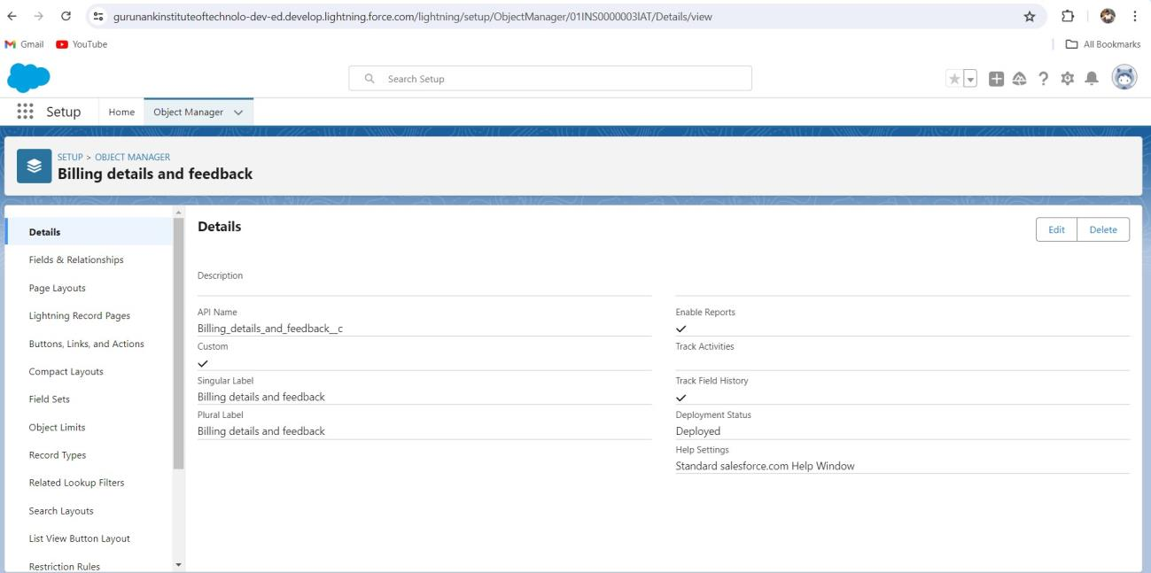

**TASK 3:CREATE TABS**

**Creating A Custom Tab**

**To create a Tab:(Customer Details)**

1. Go to setup page >> type Tabs in Quick Find bar >> click on tabs >> New (under custom object tab)

2. Select Object(Customer Details) >> Select the tab style >> Next (Add to profiles page) keep it as

default >> Next (Add to Custom App) uncheck the include tab .

3. Make sure that the Append tab to users' existing personal customizations is checked.

4. Click save.

# 

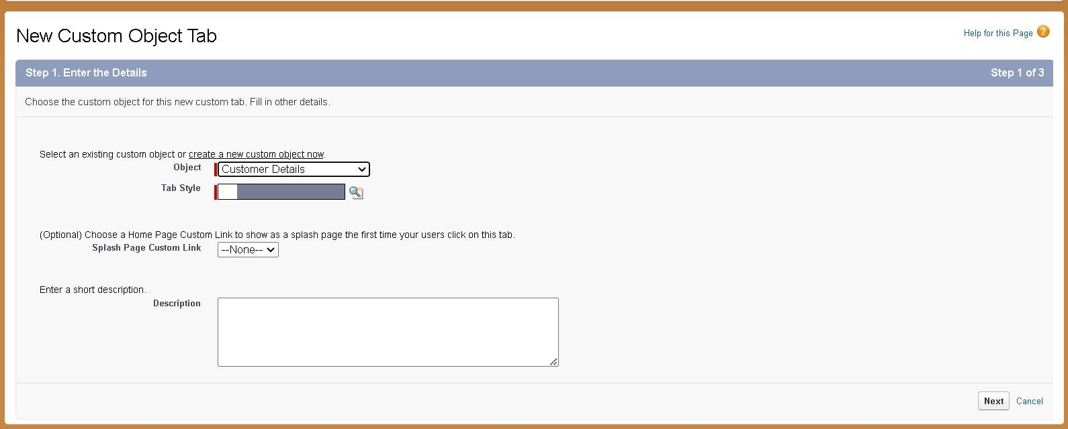

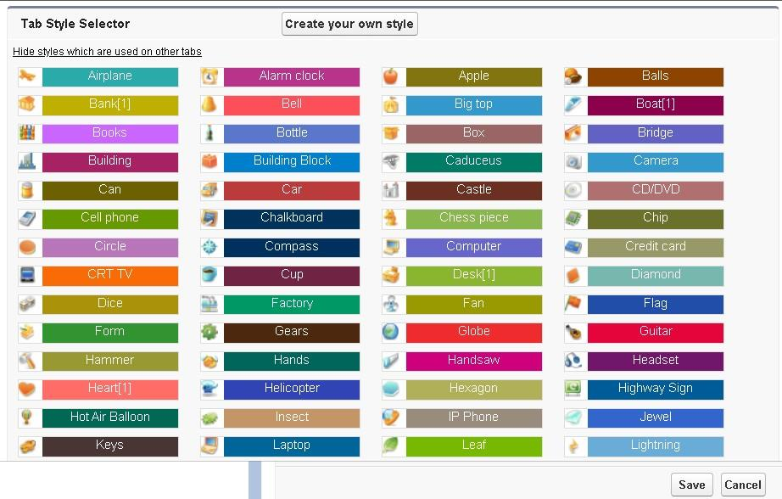

**To create a Tab:(Appointment)**

1. Go to setup page >> type Tabs in Quick Find bar >> click on tabs >> New (under custom object tab)

2. Select Object(Appointment) >> Select the tab style >> Next (Add to profiles

page) keep it as default >> Next (Add to Custom App) uncheck the include tab .

3. Make sure that the Append tab to users' existing personal customizations is checked.

4. Click save

**To create a Tab:(Service Records)**

1. Go to setup page >> type Tabs in Quick Find bar >> click on tabs >> New (under custom object tab)

2. Select Object(Service Records) >> Select the tab style >> Next (Add to profiles page) keep it as default

>> Next (Add to Custom App) uncheck the include tab .

3. Make sure that the Append tab to users' existing personal customizations is checked.

4. Click save

**To create a Tab:(**Billing details and feedback**)**

1. Go to setup page >> type Tabs in Quick Find bar >> click on tabs >> New (under custom object tab)

2. Select Object(Billing details and feedback) >> Select the tab style >> Next (Add to profiles page) keep it as default >> Next (Add to Custom App) uncheck the include tab .

3. Make sure that the Append tab to users' existing personal customizations is checked.

4. Click save

**TASK 4:CREATE THE LIGHTING APP**

To create a lightning app page:

1. Go to setup page >> search “app manager” in quick find >> select “app manager” >> click on New lightning App.

2. Fill the app name in app details as Garage Management Application >> Next >> (App option page) keep it as default >> Next >> (Utility Items) keep it as default >> Next.

3. To Add Navigation Items:

4. Select the items (Customer Details,Appointments, Service records, Billing details and feedback, Reports and Dashboards) from the search bar and move it using the arrow button >> Next.

5. To Add User Profiles:

Search profiles (System administrator) in the search bar >> click on the arrow button >> save & finish.

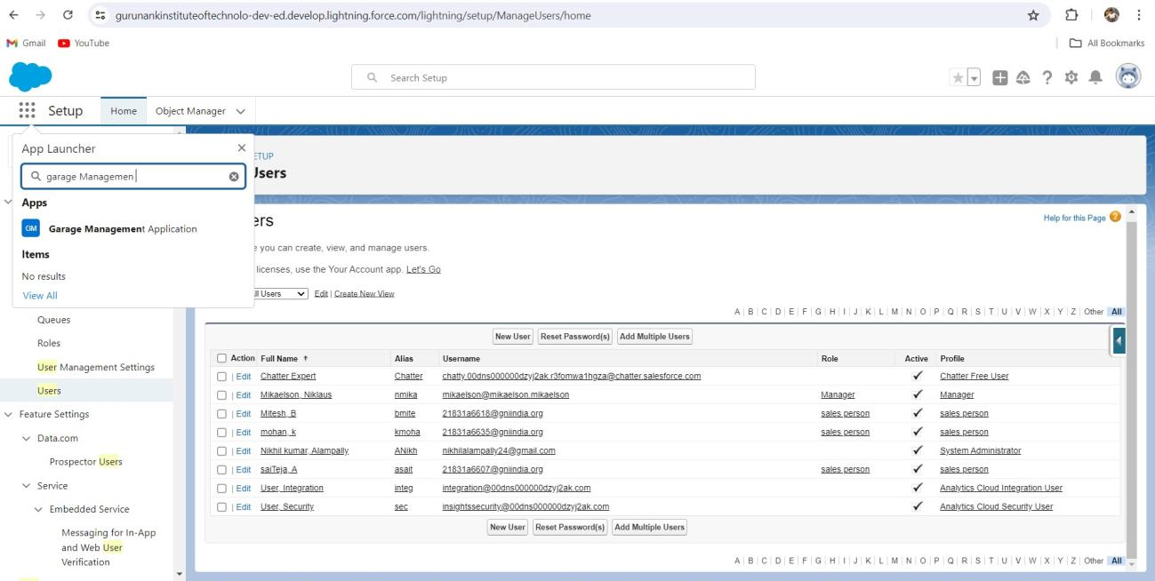

**TASK 5:CREATE THE FIELDS**

**1. To create fields in an object:**

1. Go to setup >> click on Object Manager >> type object name(Customer Details) in search bar >> click

on the object.

2. Now click on “Fields & Relationships” >> New

3. Select Data Type as a “Phone”

4. Click on next.

5. Fill the Above as following:

● Field Label: Phone number

● Field Name : gets auto generated

● Click on Next >> Next >> Save and new.

Note: Follow the above steps for the remaining field for the same object.

**2. To create another fields in an object:**

1. Go to setup >> click on Object Manager >> type object name(Customer Details) in search bar >> click on the object.

2. Now click on “Fields & Relationships” >> New

3. Select Data type as a “Email” and Click on Next

4. Fill the Above as following:

● Field Label : Gmail● Field Name : gets auto generated ● Click on Next >> Next >> Save and new.

**Creation Of Lookup Fields**

**Creation of Lookup Field on Appointment Object :**

1. Go to setup >> click on Object Manager >> type object name( Appointment ) in the search bar >>

click on the object.

2. Now click on “Fields & Relationships” >> New

3. Select “Look-up relationship” as data type and click Next.

4. Select the related object “ Customer Details” and click next.

5. Next >> Next >> Save.

Note: Make sure you complete Activity 4 Before continuing.

**Creation of Lookup Field on Service records Object :**

1. Go to setup >> click on Object Manager >> type object name( Service records ) in search bar >> click on the object.

2. Now click on “Fields & Relationships” >> New

3. Select “Look-up relationship” as data type and click Next.

4. Select the related object “Appointment” and click next.

5. Make it a required field so click on Required.

6. Scroll down for Lookup Filter and click on Show filter settings.

7. Now add the filter criteria.

8. Field : Appointment:Appointment Date >> Operator : less than >> select field >> Appointment: Created Date.

9. Filter type should be Required.

10. Error Message : Value does not match the criteria.

11. Enable the filter by click on Active.

12. Next >> Next >> Save.

**Creation of Lookup Field on Billing details and feedback Object:**

1. Go to setup >> click on Object Manager >> type object name (Billing details and feedback) in search bar >> click on the object.

2. Now click on “Fields & Relationships” >> New.

3. Select “Look-up relationship” as data type and click Next.

4. Select the related object “ Service records” and click next.

5. Next >> Next >> Save & new.

**Creation Of Checkbox Fields**

**Creation of Checkbox Field on Appointment Object :**

1. Go to setup >> click on Object Manager >> type object name ( Appointment ) in search bar >>

click on the object.

2. Now click on “Fields & Relationships” >> New.

3. Select “Check box” as data type and click Next.

4. Give the Field Label : Maintenance service

5. Field Name : is auto populated

6. Default value : unchecked

7. Click on next >> next >> save.

**Creation of Another Checkbox Field on Appointment Object :**

1. Repeat the steps form 1 to 3.

2. Give the Field Label : Repairs

3. Field Name : is auto populated

4. Default value : unchecked

5. Click on next >> next >> save.

6. Follow the same and create another checkbox with given names

7. Give the Field Label : Replacement Parts

8. Field Name : is auto populated

9. Default value : unchecked

10. Click on next >> next >> save.

**Creation of Checkbox Field on Service records Object :**

1. Go to setup >> click on Object Manager >> type object name( Service records ) in search bar >> click on the object.

2. Now click on “Fields & Relationships” >> New.

3. Select “Check box” as data type and click Next.4. Give the Field Label : Quality Check Status

5. Field Name : is auto populated

6. Default value : unchecked

7. Click on next >> next >> save.

**Creation Of Date Fields**

**Creation of Date Field on Appointment Object :**

1. Go to setup >> click on Object Manager >> type object name( Appointment ) in the search bar >> click on the object.

2. Now click on “Fields & Relationships” >> New.

3. Select “Date” as data type and click Next.

4. Give the Field Label : Appointment Date

5. Field Name : is auto populated

6. Make it as a Required field by click on the Required option.

7. Click on next >> next >> save.

**Creation Of Currency Fields**

**Creation of Currency Field on Appointment Object :**

1. Go to setup >> click on Object Manager >> type object name( Appointment ) in the search bar >> click on the object.

2. Now click on “Fields & Relationships” >> New.

3. Select “Currency” as data type and click Next.

4. Give the Field Label : Service Amount

5. Field Name : is auto populated

6. Click on next

7. Give read only for all the profiles in field level security for profile.

8. Click on next > > save.

**Creation of Currency Field on Billing details and feedback Object :**

1. Follow the same steps as mentioned above in Billing details and feedback Object.

2. Change the label name as mentioned.

3. Give the Field Label : Payment Paid.

4. Field Name : is auto populated.

**Creation Of Text Fields**

1. Go to setup >> click on Object Manager >> type object name( Appointment ) in the search bar >> click on the object.

2. Now click on “Fields & Relationships” >> New.

3. Select “Text” as data type and click Next.

4. Give the Field Label : Vehicle number plate

5. Field Name : is auto populated

6. Length : 10

7. Make field as Required and Unique.

8. Click on next >> next >> save.

**Creation of Text Fields in Billing details and feedback object :**

1. Go to setup >> click on Object Manager >> type object name( Billing details and feedback ) in search bar >> click on the object.

2. Now click on “Fields & Relationships” >> New.

3. Select “text” as data type and click Next.

4. Give the Field Label : Rating for service

5. Field Name : is auto populated

6. Length : 1

7. Make field as Required and Unique.

8. Click on next >> next >> save.

**Creation Of Picklist Fields**

**Creation of Picklist Fields in Service records object :**

1. Go to setup >> click on Object Manager >> type object name(Service records) in search bar >>

click on the object.

2. Click on fields & relationship >> click on New.

3. Select Data type as “Picklist” and click Next.

4. Enter Field Label as “Service Status”, under values select “Enter values, with each value separated by a new line" and enter values as shown below.

5. The values are: Started, Completed

6. Click Next.

7. Next >> Next >> Save.

**Creation of Picklist Fields in Billing details and feedback object :**

1. Go to setup >> click on Object Manager >> type object name(Billing details and feedback) in search bar >> click on the object.

2. Click on fields & relationship >> click on New.

3. Select Data type as “Picklist” and click Next.

4. Enter Field Label as “Payment Status”, under values select “Enter values, with each value separated by a new line" and enter values as shown below.

5. The values are: Pending, Completed.

6. Click Next.

**Creating Formula Field In Service Records Object**

1. Go to setup >> click on Object Manager >> type object name(Service records) in search bar >> click on the object.

2. Click on fields & relationship >> click on New.

3. Select Data type as “Formula” and click Next.

4. Give Field Label and Field Name as “service date” and select formula return type as “Date” and click next.

5. Insert field formula should be : CreatedDate

6. click “Check Syntax” .

7. Click next >> next >> Save.

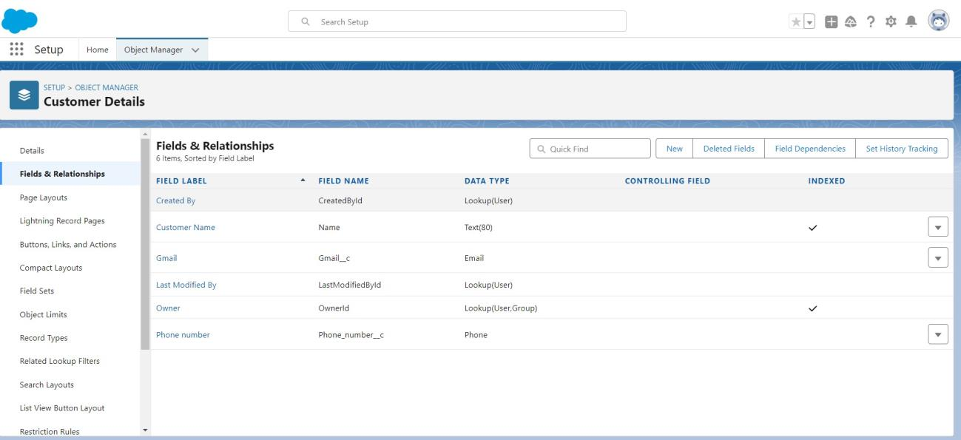

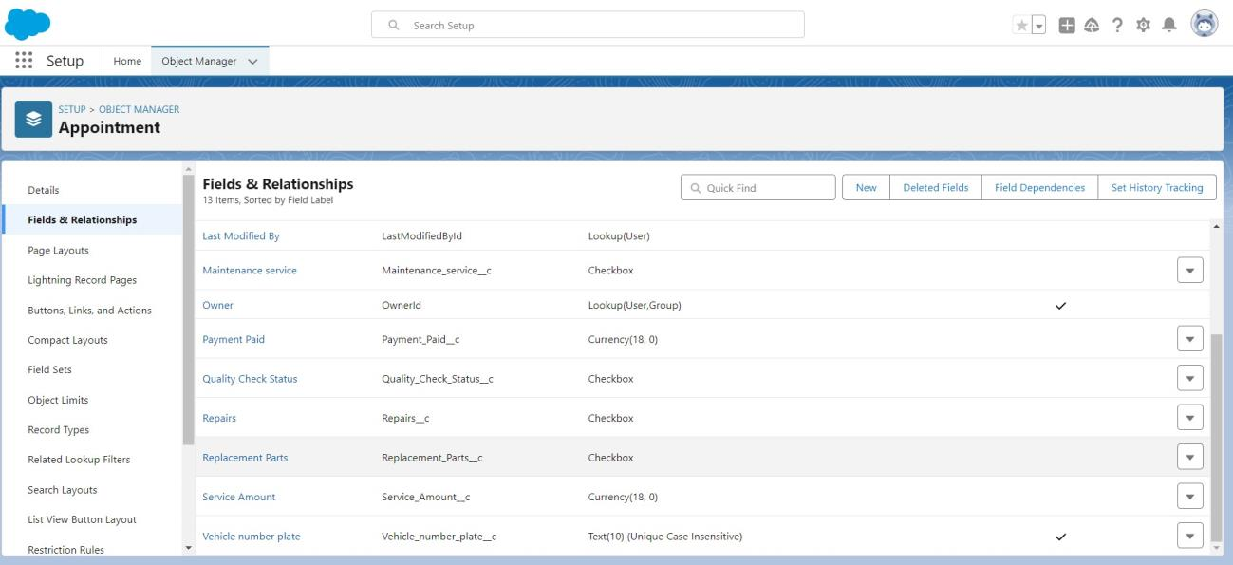

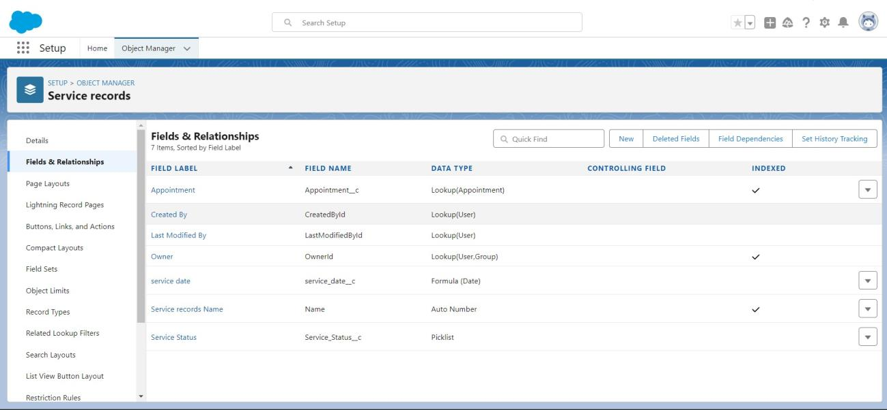

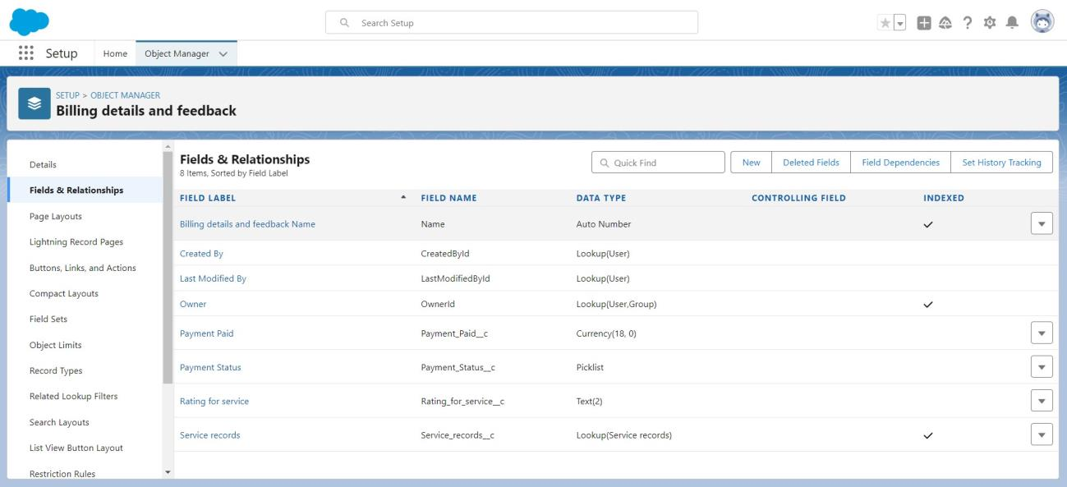

**To Create A Validation Rule To An Appointment Object**

1. Go to the setup page >> click on object manager >> From drop down click edit for Appointment object.

2. Click on the validation rule >> click New.

3. Enter the Rule name as “ Vehicle ”.

4. Insert the Error Condition Formula as : -

NOT(REGEX( Vehicle_number_plate__c , "[A-Z]{2}[0-9]{2}[A-Z]{2}[0-9]{4}"))

5. Enter the Error Message as “Please enter valid number ”, select the Error location as Field and select the field as “Vehicle number plate”, and click Save.

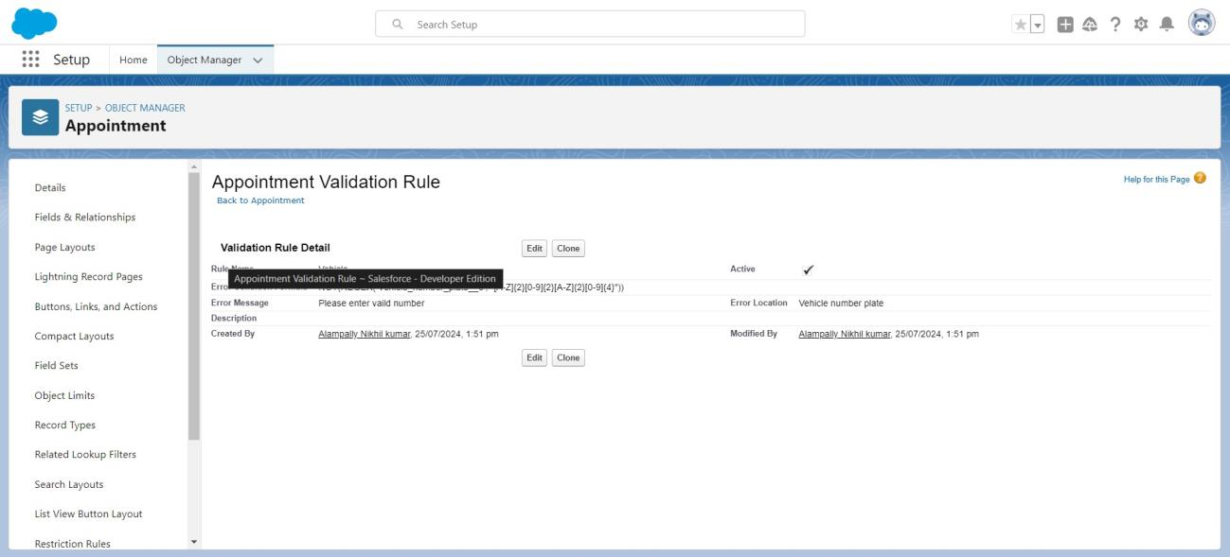

**To Create A Validation Rule To An Service Records Object**

1. Go to the setup page >> click on object manager >> From drop down click edit for Service records object.

2. Click on the validation rule >> click New.

3. Enter the Rule name as “ service_status_note ”.

4. Insert the Error Condition Formula as : -

NOT( ISPICKVAL( Service_Status__c , "Completed"))

5. Enter the Error Message as “still it is pending”, select the Error location as Field and select the field as “Service status”, and click Save.

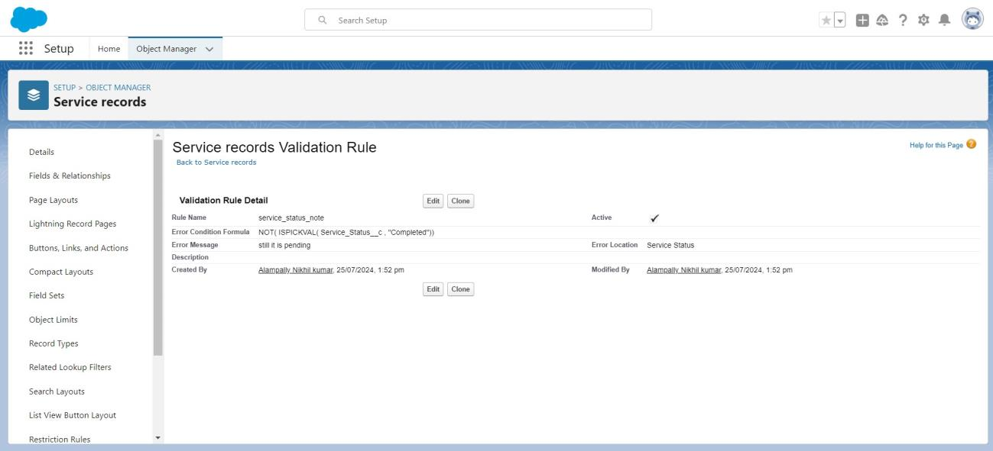

**To Create A Validation Rule To An Billing Details And Feedback Object**

1. Go to the setup page >> click on object manager >> From drop down click edit for Billing details and feedback object.

2. Click on the validation rule >> click New.

3. Enter the Rule name as “ rating_should_be_less_than_5”.

4. Insert the Error Condition Formula as : -

NOT( REGEX( Rating_for_service__c , "[1-5]{1}"))

5. Enter the Error Message as “rating should be from 1 to 5”, select the Error location as Field and select the field as “Rating for Service”, and click Save.



**TASK 7:DUPLICATE RULE**

**To Create A Matching Rule To An Customer Details Object**

1. Go to quick find box in setup and search for matching Rule.

2. Click on matching rule >> click on New Rule.

3. Select the object as Customer details and click Next.

4. Give the Rule name : Matching customer details

5. Unique name : is auto populated

6. Define the matching criteria as

7. Field Matching Method

1. Gmail Exact

2. Phone Number Exact

8. Click save.

9.After Saving Click on Activate.

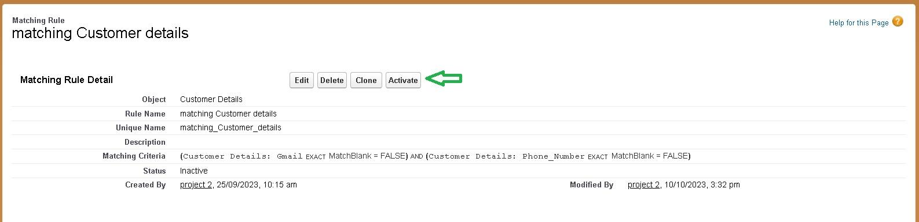

**To Create A Duplicate Rule To An Customer Details Object**

1. Go to quick find box in setup and search for Duplicate rules.

2. Click on Duplicate rule >> click on New Rule >> select customer details object.

3. Give the Rule name as : Customer Detail duplicate

4. Scroll a little in Matching rule section

5. Select the matching rule : Matching customer details

6. And Click on save.

7. After saving the Duplicate Rule, Click on Activate.

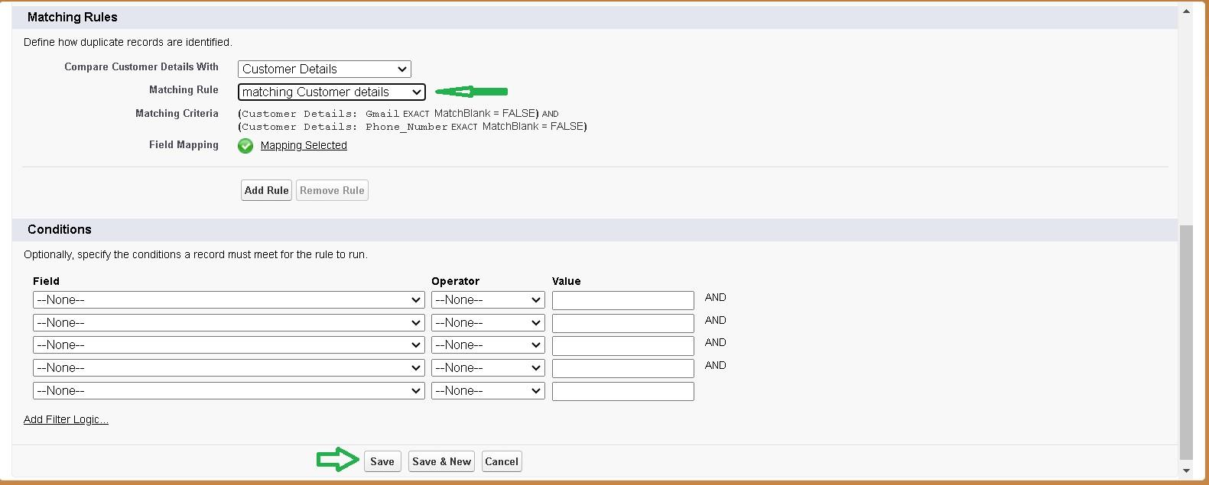

**TASK 8: CREATE PROFILES**

**To Create A Duplicate Rule To An Customer Details Object**

1. Go to quick find box in setup and search for Duplicate rules.

2. Click on Duplicate rule >> click on New Rule >> select customer details object.

3. Give the Rule name as : Customer Detail duplicate

4. Scroll a little in Matching rule section

5. Select the matching rule : Matching customer details

6. And Click on save.

7. After saving the Duplicate Rule, Click on Activate.

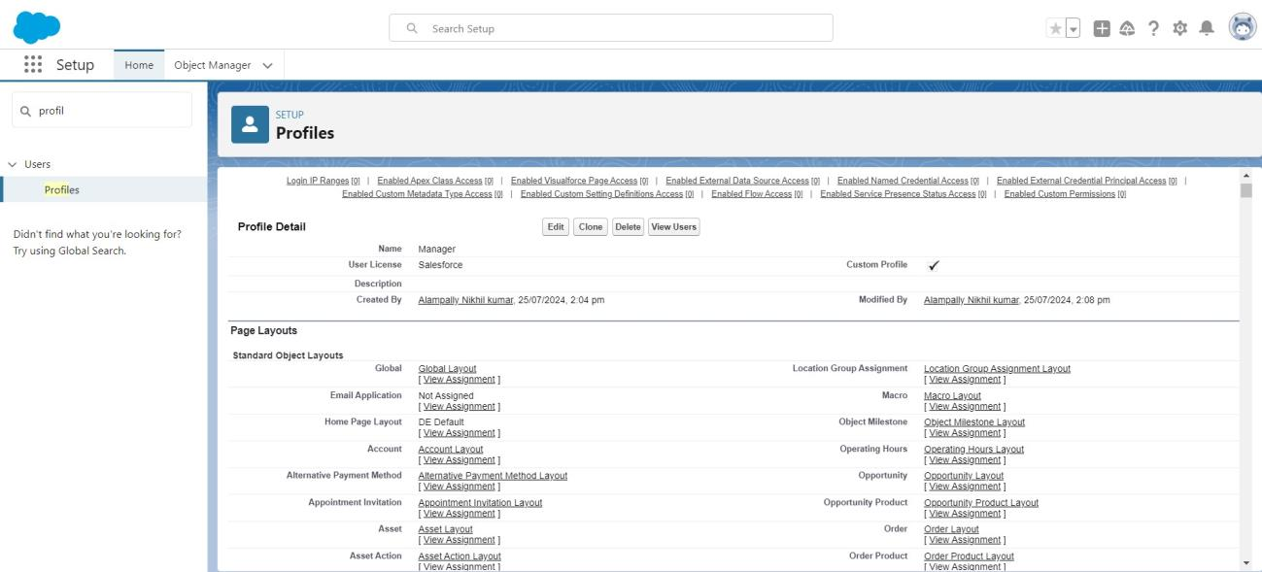

**Sales Person Profile**

1. Go to setup >> type profiles in quick find box >> click on profiles >> clone the desired profile

(Salesforce Platform User) >> enter profile name (sales person) >> Save.

2. While still on the profile page, then click Edit.

3. Select the Custom App settings as default for the GArage management.

4. Scroll down to Custom Object Permissions and Give access permissions for Appointments,Billing details and feedback , service records and customer details objects as mentioned in the below diagram.

5. And click save.

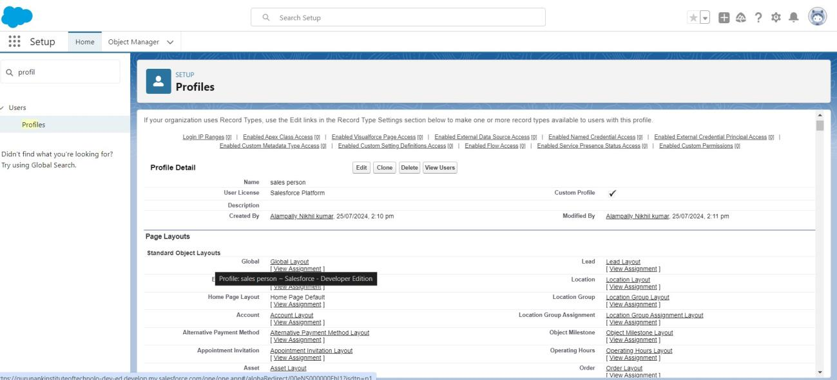

**TASK 9:Role & Role Hierarchy**

Creating Manager Role:

1. Go to quick find >> Search for Roles >> click on set up roles.

2. Click on Expand All and click on add role under whom this role works.

3. Give Label as “Manager” and Role name gets auto populated. Then click on Save.

**Creating Another Roles**

Creating another two roles under manager

1. Go to quick find >> Search for Roles >> click on set up roles.

2. Click plus on CEO role, and click add role under manager.

3. Give Label as “sales person” and Role name gets auto populated. Then click on Save.

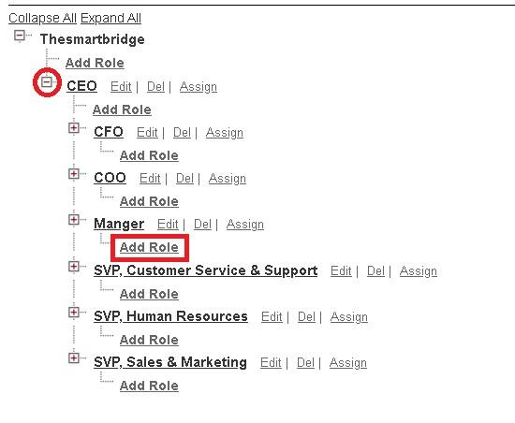

**TASK 10:USERS**

**Create User**

i.Go to setup >> type users in quick find box >> select users >> click New user.

ii.Fill in the fields

1. First Name : Nicklaus

2. Last Name : Mikaelson

3. Alias : Give a Alias Name

4. Email id : Give your Personal Email id

5. Username : Username should be in this form: text@text.text

6. Nick Name : Give a Nickname

7. Role : Manager

8. User license : Salesforce

9. Profiles : Manager

iii.Save.

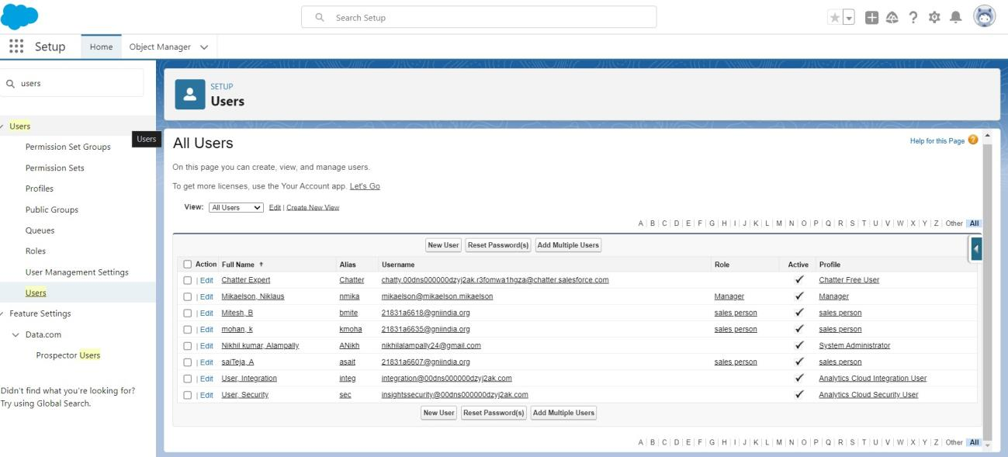

**TASK 11:PUBLIC GROUPS**

**Creating New Public Group**

1. Go to setup >> type users in quick find box >> select public groups >> click New.

2. Give the Label as “sales team”.

3. Group name is auto populated.

4. Search for Roles.

5. In Available Members select Sales person and click on add it will be moved to selected member.

6. Click on save.

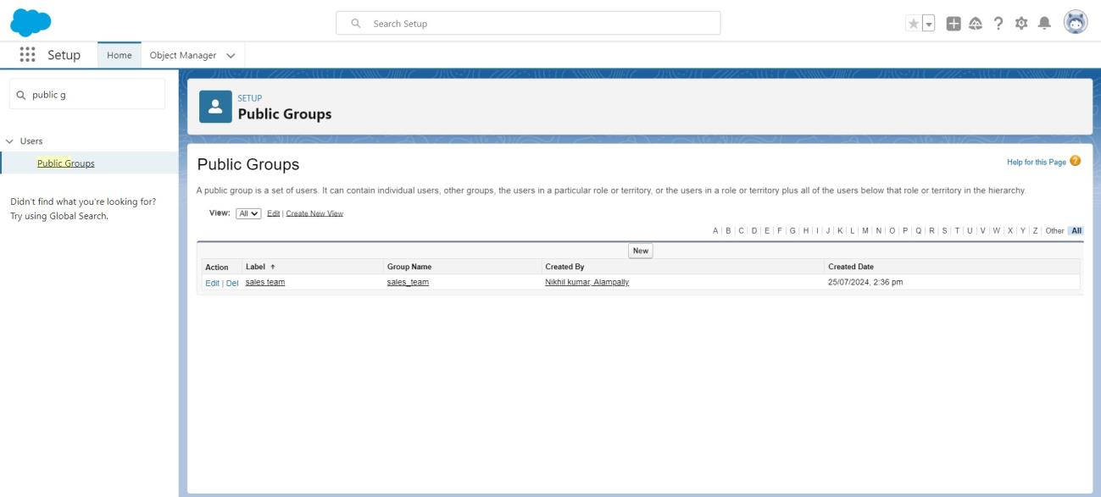

**TASK 12:SHARE SETTING**

**Creating Sharing Settings**

1. Go to setup >> type users in quick find box >> select Sharing Settings >> click Edit.

2. Change the OWD setting of the Service records Object to private as shown in fig.

3. Click on save and refresh.

4. Scroll down a bit, Click new on Service records sharing Rules.

6. Give the Label name as “ Sharing setting”

7. Rule name is auto populated.

8. In step 3 : Select which records to be shared, members of “ Roles ” >> “ Sales person”

9. In step 4: share with, select “ Roles ” >> “ Manager ”

10. In step 5 : Change the access level to “ Read / write ”.

11. Click on save.

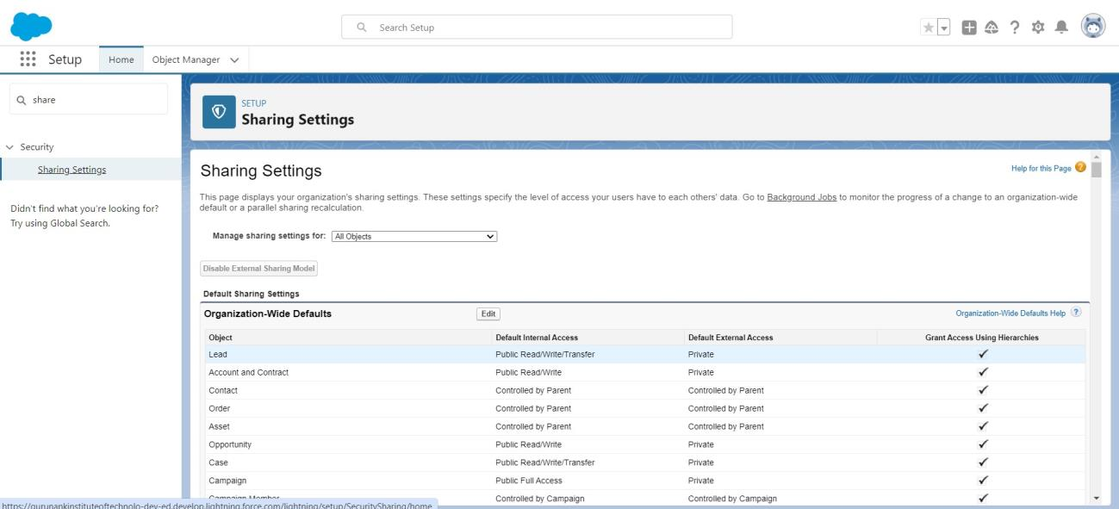

**TASK 13:FLOWS**

**Create A Flow**

1. Go to setup >> type Flow in quick find box >> Click on the Flow and Select the

New Flow.

2. Select the Record-triggered flow and Click on Create.

3. Select the Object as “Billing details and feedback”in the Drop down list.

4. Select the Trigger Flow when: “A record is Created or Updated”.5. Select the Optimize the flow for: “Actions and Related Records” and Click on Done.

6. Under the Record-triggered Flow Click on “+” Symbol and In the Drop down List select the “Update records Element”.

7. Give the Label Name : Amount Update

8. Api name : is auto populated

Set a filter condition : All Conditions are met(AND)

9. Field : Payment_Status__c

10. Operator : Equals

11. Value : Completed

12. And Set Field Values for the Billing details and feedback Record

13. Field : Payment_Paid__c

14.Value: {!$Record.Service_records__r.Appointment__r.Service_Amount__c}

15. Click On Done.

17. Before creating another Element. Create a New Resource form Toolbox form top left.

18. Click on the New Resource, And select Variable.

19. Select the resource type as text template.

20. Enter the API name as “ alert”.

21. Change the view as Rich Text ? View to Plain Text.

22. In body field paste the syntax that given below.

Dear {!$Record.Service_records__r.Appointment__r.Customer_Name__r.Name},

I hope this message finds you well. I wanted to take a moment to express my sincere gratitude for your recent payment for the services provided by our garage management team. Your prompt payment is greatly appreciated, and it helps us continue to provide top-notch services to you and all our valued customers.

Amount paid : {!$Record.Payment_Paid__c} Thank you for Coming

23. Click done.

24. Now Click on Add Element , select Action.

25. Their action bar will be opened in that search for “send email ” and click on it.

26. Give the label name as “ Email Alert”

27. API name will be auto populated.

28. Enable the body in set input values for the selected action.

29. Select the text template that created , Body : {!alert}

30. Include recipient address list select the email form the record.31. RecipientAddressList:

{!$Record.Service_records__r.Appointment__r.Customer_Name__r.Gmail__c}

32. Include subject as “ Thank You for Your Payment - Garage Management”.

33. Click done.

34. Click on save. Give the Flow label , Flow Api name will be auto populated. 35. And click save, and click on activate.

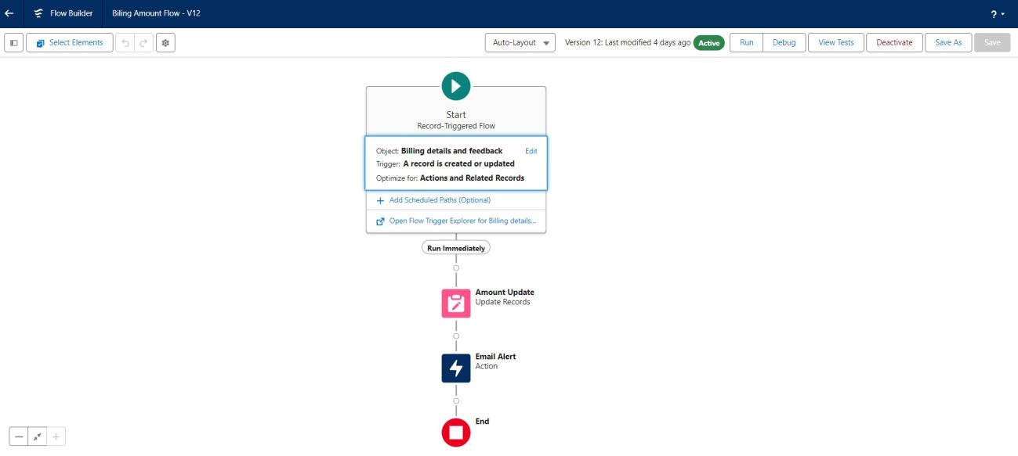

**TASK 14:APEX TRIGGER**

**Apex Handler**

UseCase : This use case works for Amount Distribution for each Service the customer selected for there Vehicle.

1. Login to the respective trailhead account and navigate to the gear icon in the top right corner.

2. Click on the Developer console. Now you will see a new console window.

3. In the toolbar, you can see FILE. Click on it and navigate to new and create New apex class.

4. Name the class as “AmountDistributionHandler ”.

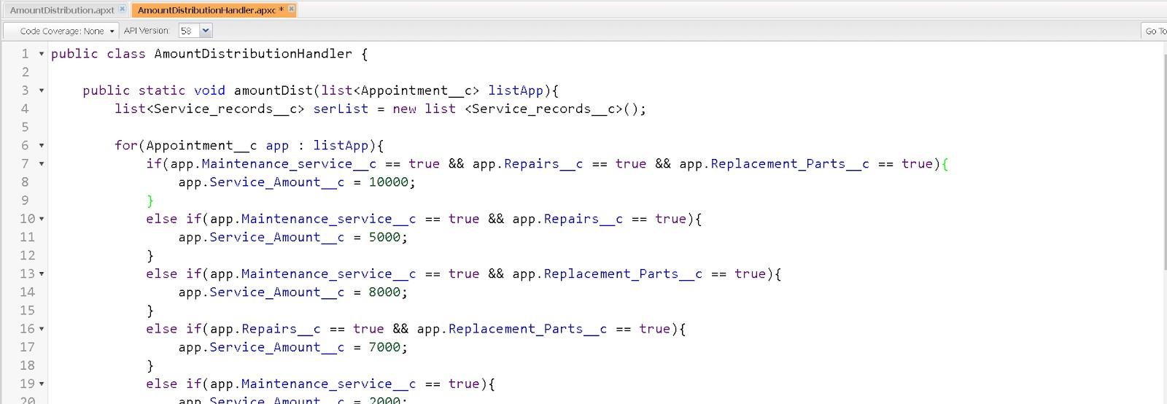

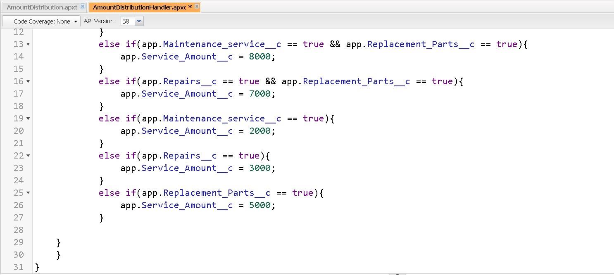

**Trigger Handler:**

How to create a new trigger :

1. While still in the trailhead account, navigate to the gear icon in the top right corner.

2. Click on developer console and you will be navigated to a new console window.

3. Click on File menu in the tool bar, and click on new? Trigger.

4. Enter the trigger name and the object to be triggered.

5. Name : AmountDistribution

6. sObject : Appointment__c

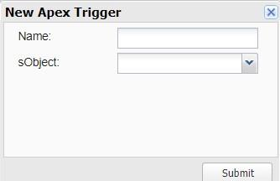

Syntax For creating trigger :

The syntax for creating trigger is :

Trigger [trigger name] on [object name]( Before/After event)

{

}

In this project , trigger is called whenever the particular records sum exceed the threshold i.e minimum

business requirement value. Then the code in the trigger will get executed.

1. Handler for the Appointment Object

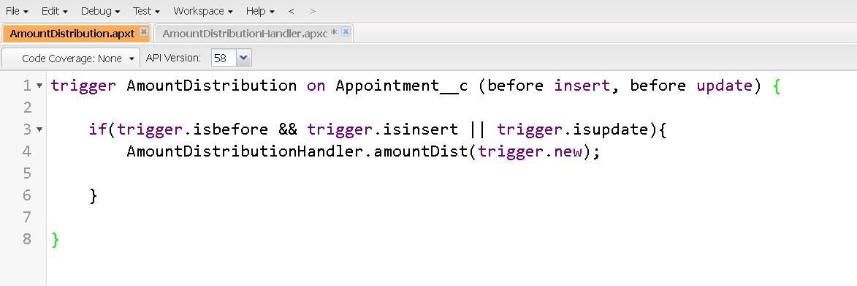

**TASK 15: REPORTS**

**Create A Report Folder**

1. Click on the app launcher and search for reports.

2. Click on the report tab, click on new folder.

3. Give the Folder label as “Garage Management Folder”, Folder unique name will be auto populated.

4. Click save.

**Sharing A Report Folder**

1. Go to the app >> click on the reports tab.

2. Click on the All folder , click on the Drop down arrow for Garage Management folder, and Click on share.

3. Select the share with as “roles”, in name field search for “manager”, give “view” as access for that role.

4. Then click share, and click on Done.

**Create Report Type**

1. Go to setup >> type users in quick find box >> select Report Type >> click on Continue.

2. Click on new custom report type.

3. Select the Primary object as “ Customer details” .

4. Give the Report type Label as “ Service information ”

5. Report type Name is autopopulated.

6. Keep the Description as same.

7. Select Store in Category as “ other Reports ”

8. Select the deployment status as “ Depolyed ”, click on Next.

9. now , Click on Related object box.

10. Click on Select Object, choose Appointment Object as shown in fig.

11. Again Click to relate another object.

12. And select the related object as “ service records”.

13. Repeat the process and select the related object as “ Billing details and feedback”.

14. And click on save.

**Create Report**

**Note : Before creating report, create latest “10” records in every object. Try to fill every field**

**in each record for better experience.**

1. Go to the app >> click on the reports tab

2. Click New Report.

3. Select the Category as other reports, search for Service Information, select that report, click on it. And click on start report.

4. Their outline pane is opened already, select the fields that mentioned below in column section.

1. Customer name

2. Appointment Date

3. Service Status

4. Payment paid

5. Remove the unnecessary fields.

6. Select the fields that mentioned below in GROUP ROWS section. 1. Rating for Service

7. Select the fields that mentioned below in GROUP ROWS section.

1. Payment Status

8. Click on Add Chart , Select the Line Chart.

9. Click on save, Give the report Name : New Service information Report

10. Report unique Name is auto populated.

11. Select the folder the created and Click on save.

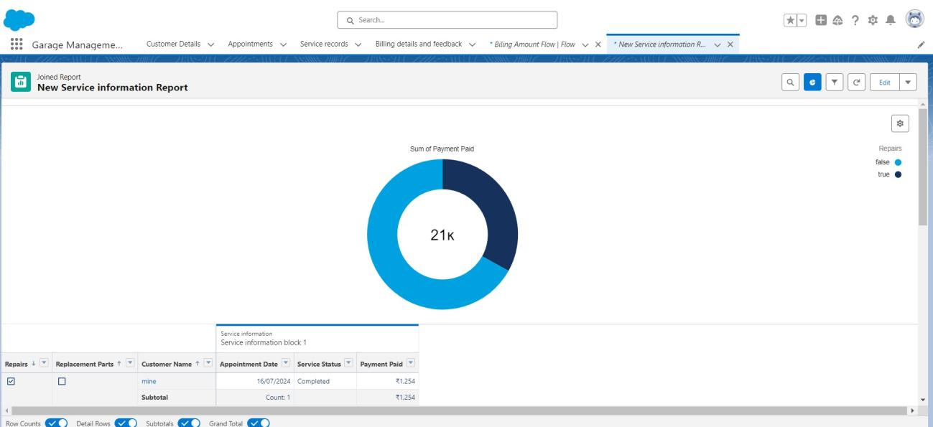

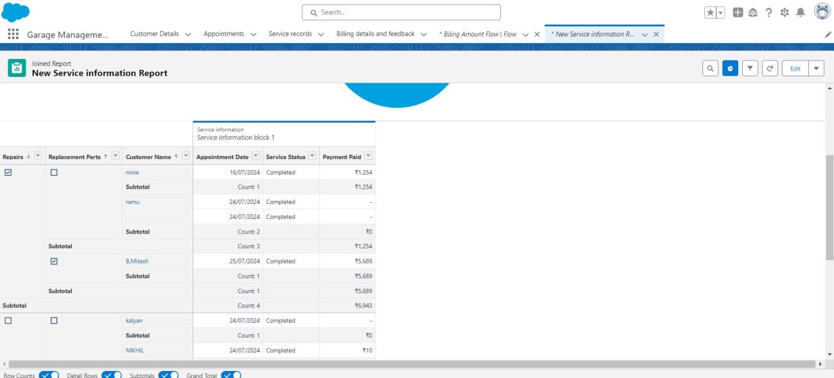

**TASK 16: DASHBOARD**

**Create Dashboard Folder**

1. Click on the app launcher and search for dashboard.

2. Click on dashboard tab.

3. Click new folder, give the folder label as “ Service Rating dashboard”.

4. Folder unique name will be auto populated.

5. Click save.

6. Follow the same steps, form milestone 15, and activity 2, and provide the sharing settings for the folder that just created.

**Create Dashboard**

1. Go to the app >> click on the Dashboards tabs.

2. Give a Name and select the folder that created, and click on create.

3. Select add component.

4. Select a Report and click on select.

5. Select the Line Chart. Change the theme.

6. Click Add then click on Save and then click on Done.

7. Preview is shown below.

8. After that Click on Subcribe on top right.

9. Set the Frequency as “ weekly ”.

10. Set a day as monday.

11. And Click on save.

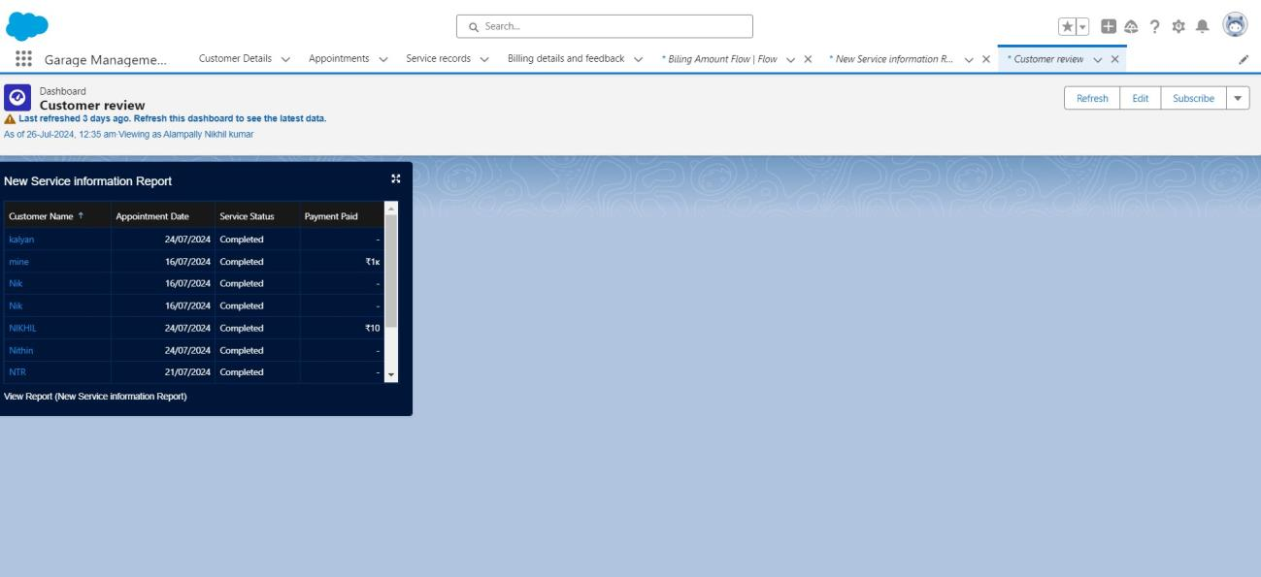

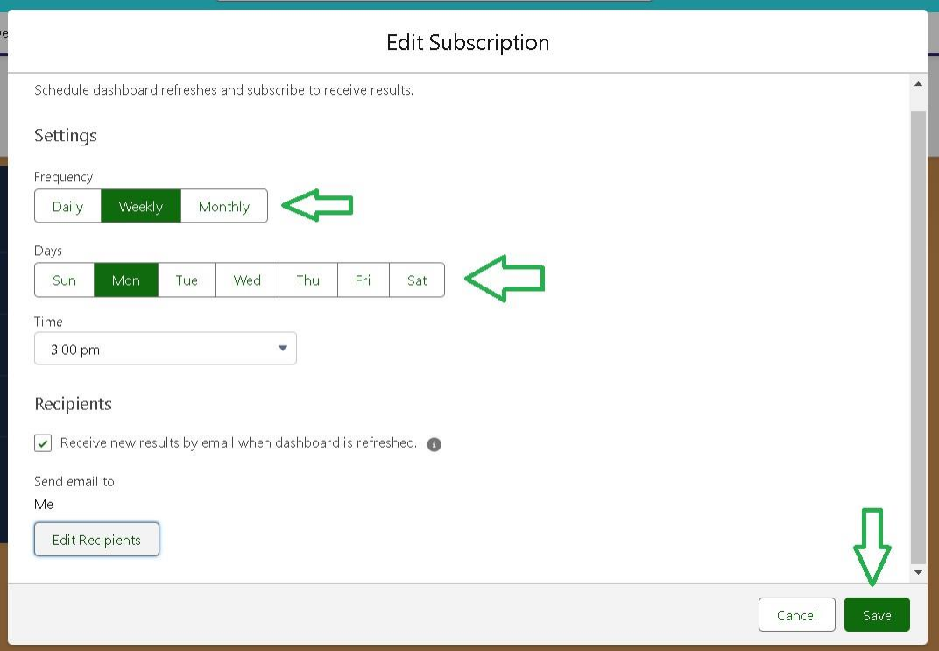

# 5. Testing and Validation

Describe the approach to testing:

● **Unit Testing (apex classes, Triggers).**

* **Apex Classes**:
  + Created and tested Apex classes for core functionalities, such as automated updates in the **Service Records** object and validations in the **Billing** object.
  + Used Salesforce's **Apex Test Framework** to write test classes for custom logic.
  + Verified that business logic behaves correctly for various scenarios.
  + Achieved a minimum of 75% code coverage, as required by Salesforce.
* **Triggers**:
  + Tested Apex triggers for operations like:
    - Automatically updating **Service Records** when a **Customer Appointment** is marked as "Completed."
    - Sending notifications upon specific actions (e.g., new feedback submission).
  + Ensured no recursive trigger loops or conflicts with existing workflows.

● **User Interface Testing**.

* **Page Layouts**:
* Validated that each object's page layout displays relevant fields based on user roles.
* Confirmed that required fields (e.g., "Customer Name" in **Appointments**) are enforced on the UI.
* **Lightning Components**:
* Tested custom Lightning components for user interactions, including navigation and data entry.
* Verified responsiveness and compatibility across devices (desktop, tablet, mobile).

• **Forms and Validations**:

* Checked that all forms (e.g., appointment booking and billing) enforce field validations and show error messages appropriately.

## 6. Key Scenarios Addressed by Salesforce in the Implementation Project

 The Salesforce Garage Management System (GMS) effectively addresses several critical use cases to improve operational efficiency, customer satisfaction, and data management. Here are the key scenarios handled during the implementation:



#### **1. Customer and Vehicle Management**

* **Scenario**: A new customer visits the garage and needs their details and vehicle information recorded.
* **Solution**:
  + Salesforce's **Customer Details** object allows streamlined input of customer information, including contact and vehicle details.
  + Lookup relationships between the **Customer Details** and **Service Records** objects ensure seamless tracking of repair histories.

#### **2. Appointment Scheduling and Tracking**

* **Scenario**: A customer books a repair or service appointment for their vehicle.
* **Solution**:
  + The **Appointment** object handles scheduling, tracks appointment details, and notifies staff and customers of booking confirmations.
  + Automated reminders are sent using **Process Builder** or **Flow Builder** to ensure timely updates.

#### **3. Service Management**

* **Scenario**: A mechanic is assigned to a repair job, and the status of the job needs to be updated in real-time.
* **Solution**:
  + The **Service Records** object logs service details such as job type, assigned mechanic, and current status (e.g., "In Progress," "Completed").





* + Custom triggers automatically update job statuses and notify relevant staff when changes occur.

#### **4. Billing and Payments**

* **Scenario**: After a service is completed, the customer receives an invoice for the payment.
* **Solution**:
  + The **Billing** object generates invoices, records payment status, and tracks pending dues.
  + Automated alerts are triggered for overdue payments, ensuring timely follow-ups.

#### **5. Inventory Management**

* **Scenario**: A repair job requires specific parts, and the garage needs to ensure adequate stock.
* **Solution**:
  + Inventory is tracked in a custom object with fields for stock levels, part details, and reorder thresholds.
  + Automated low-stock alerts are generated using **Flow Builder** to maintain optimal inventory levels.

#### **6. Feedback Collection and Analysis**

* **Scenario**: After a service, customers are asked to provide feedback.
* **Solution**:
  + The **Feedback** object collects customer reviews, ratings, and comments.
  + Dashboards display feedback trends to help the garage identify strengths and areas for improvement.

#### **7. Real-time Reporting and Insights**

* **Scenario**: The garage manager wants an overview of operational metrics like revenue, completed jobs, and customer satisfaction.
* **Solution**:





* + Salesforce **Reports and Dashboards** provide insights into key performance indicators (KPIs).
  + Customizable reports enable detailed analysis, such as staff performance and monthly revenue trends.

#### **8. Data Security and Access Control**

* **Scenario**: Sensitive customer and billing information must be accessible only to authorized users.
* **Solution**:
  + Implemented **Profiles, Roles, and Field-Level Security** to restrict access to confidential data.
  + Ensures compliance with data privacy standards while enabling efficient collaboration.

#### **9. Customer Engagement and Retention**

* **Scenario**: A garage wants to send regular maintenance reminders to customers based on service history.
* **Solution**:
  + Scheduled flows send personalized emails to customers, reminding them of upcoming services or maintenance check-ups.
  + Promotes long-term customer relationships and loyalty.

# 7. Conclusion

**Summary of Achievements:**

The Salesforce Garage Management System (GMS) successfully achieves its primary goal of streamlining operations and enhancing customer satisfaction within the automotive repair industry. Key accomplishments include:





* **Centralized Data Management**:
  + Created an integrated system to store and manage customer, vehicle, appointment, service, and billing information.
* **Enhanced Operational Efficiency**:
  + Automated appointment scheduling, service updates, and billing processes, reducing manual effort and errors.
* **Improved Customer Engagement**:
  + Enabled personalized notifications and reminders, fostering stronger customer relationships and retention.
* **Comprehensive Reporting and Insights**:
  + Implemented real-time dashboards and reports to track KPIs like revenue, customer satisfaction, and operational performance.
* **Scalable and Secure System**:
  + Designed the system with robust access controls, ensuring data privacy and enabling scalability for future needs.
* **Seamless User Experience**:
  + Developed user-friendly interfaces and workflows for both customers and garage staff, ensuring ease of use and adoption.

This project demonstrates the transformative potential of Salesforce in addressing critical business challenges and delivering innovative, scalable solutions.